Rectangle

#include <GL/gl.h>

#include <GL/glut.h>

void display(void)

{

/* clear all pixels */

glClear (GL_COLOR_BUFFER_BIT);

/* draw white polygon (rectangle) with corners at

* (0.25, 0.25, 0.0) and (0.75, 0.75, 0.0)

*/

glColor3f (1.0, 0.0, 0.0);

glBegin(GL_POLYGON);

glVertex3f (0.25, 0.25, 0.0);

glVertex3f (0.75, 0.25, 0.0);

glVertex3f (0.75, 0.75, 0.0);

glVertex3f (0.25, 0.75, 0.0);

glEnd();

/* don't wait!

* start processing buffered OpenGL routines

*/

glFlush ();

}

void init (void)

{

/* select clearing (background) color */

glClearColor (0.0, 0.0, 0.0, 0.0);

/* initialize viewing values */

glMatrixMode(GL_PROJECTION);

glLoadIdentity();

glOrtho(0.0, 1.0, 0.0, 1.0, -1.0, 1.0);

}

/*

* Declare initial window size, position, and display mode

* (single buffer and RGBA). Open window with "hello"

* in its title bar. Call initialization routines.

* Register callback function to display graphics.

* Enter main loop and process events.

*/

int main(int argc, char** argv)

{

glutInit(&argc, argv);

glutInitDisplayMode (GLUT_SINGLE | GLUT_RGB);

glutInitWindowSize (500, 500);

glutInitWindowPosition (100, 100);

glutCreateWindow ("hello");

init ();

glutDisplayFunc(display);

glutMainLoop();

return 0; /* ISO C requires main to return int. */}

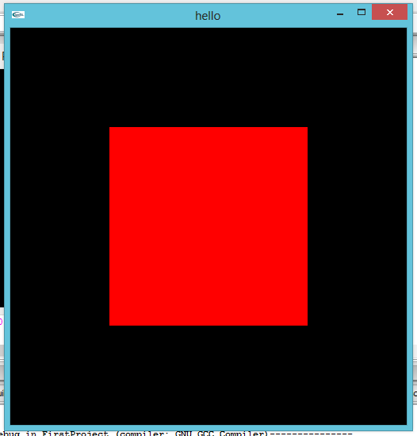

Triangle 1

#include <GL/gl.h>

#include <GL/glut.h>

void display(void)

{

/* clear all pixels */

glClear (GL_COLOR_BUFFER_BIT);

/* draw white polygon (rectangle) with corners at

* (0.25, 0.25, 0.0) and (0.75, 0.75, 0.0)

*/

glColor3f (1.0, 0.0, 0.0);

glBegin(GL_POLYGON);

glVertex3f (0.4, 0.4, 0.0);

glVertex3f (0.6, 0.4, 0.0);

glVertex3f (0.5, 0.6, 0.0);

glEnd();

/* don't wait!

* start processing buffered OpenGL routines

*/

glFlush ();

}

void init (void)

{

/* select clearing (background) color */

glClearColor (0.0, 0.0, 0.0, 0.0);

/* initialize viewing values */

glMatrixMode(GL_PROJECTION);

glLoadIdentity();

glOrtho(0.0, 1.0, 0.0, 1.0, -1.0, 1.0);

}

/*

* Declare initial window size, position, and display mode

* (single buffer and RGBA). Open window with "hello"

* in its title bar. Call initialization routines.

* Register callback function to display graphics.

* Enter main loop and process events.

*/

int main(int argc, char** argv)

{

glutInit(&argc, argv);

glutInitDisplayMode (GLUT_SINGLE | GLUT_RGB);

glutInitWindowSize (500, 500);

glutInitWindowPosition (500, 100);

glutCreateWindow ("hello");

init ();

glutDisplayFunc(display);

glutMainLoop();

return 0; /* ISO C requires main to return int. */}

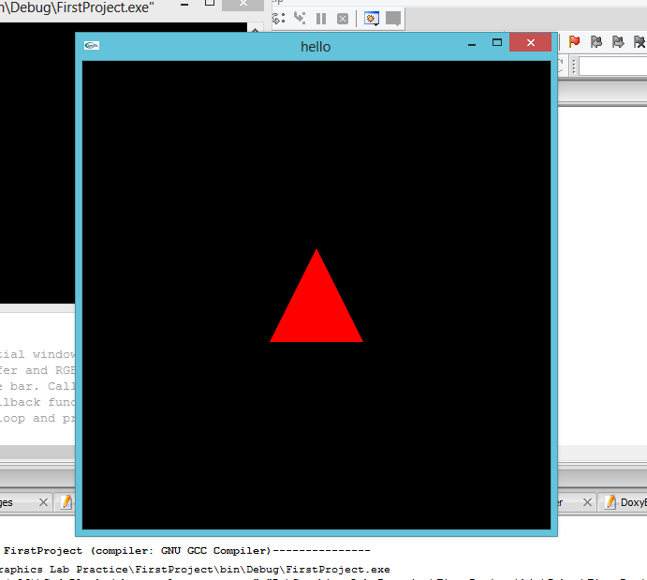

Triangle 2

#include <GL/gl.h>

#include <GL/glut.h>

void display(void)

{

/* clear all pixels */

glClear (GL_COLOR_BUFFER_BIT);

/* draw white polygon (rectangle) with corners at

* (0.25, 0.25, 0.0) and (0.75, 0.75, 0.0)

*/

glColor3f (1.0, 0.0, 0.0);

glBegin(GL_POLYGON);

glVertex3f (0.4, 0.4, 0.0);

glVertex3f (0.6, 0.4, 0.0);

glVertex3f (0.5, 0.2, 0.0);

glEnd();

/* don't wait!

* start processing buffered OpenGL routines

*/

glFlush ();

}

void init (void)

{

/* select clearing (background) color */

glClearColor (0.0, 0.0, 0.0, 0.0);

/* initialize viewing values */

glMatrixMode(GL_PROJECTION);

glLoadIdentity();

glOrtho(0.0, 1.0, 0.0, 1.0, -1.0, 1.0);

}

/*

* Declare initial window size, position, and display mode

* (single buffer and RGBA). Open window with "hello"

* in its title bar. Call initialization routines.

* Register callback function to display graphics.

* Enter main loop and process events.

*/

int main(int argc, char** argv)

{

glutInit(&argc, argv);

glutInitDisplayMode (GLUT_SINGLE | GLUT_RGB);

glutInitWindowSize (500, 500);

glutInitWindowPosition (500, 100);

glutCreateWindow ("hello");

init ();

glutDisplayFunc(display);

glutMainLoop();

return 0; /* ISO C requires main to return int. */}

